2025 Go Healthy with Taiwan:
Official Launch of Global Call for Proposals

To enhance Taiwan’s global visibility in the health industry and promote international cooperation with local implementation, the International Trade Administration (TITA) under the Ministry of Economic Affairs (MOEA) has commissioned the Taiwan External Trade Development Council (TAITRA) to initiate a worldwide call for proposals under the theme “Go Healthy with Taiwan.”

This global campaign seeks to engage governments, institutions, enterprises, and organizations from around the world to submit innovative proposals that integrate Taiwan’s high-quality health products and holistic solutions. The objective is to jointly improve global health standards and promote well-being in cities, communities, and business environments across the globe.

The “Go Healthy with Taiwan” campaign spotlights five key sectors of Taiwan’s health industry: smart healthcare technologies, medical aesthetics and wellness checkups, fitness equipment, sports technologies, and bicycles. Taiwan, long recognized as the “Bicycle Kingdom,” boasts a robust and integrated bicycle industry cluster and leading R&D capabilities. As a global hub for high-end bicycle manufacturing, Taiwan is also driving the transition toward net-zero emissions and playing a pivotal role in global sustainable supply chains.

Furthermore, Taiwanese companies are among the world’s top suppliers of fitness equipment, setting international benchmarks through the integration of AI technologies and supported by a strong manufacturing and R&D ecosystem. In the smart healthcare field, Taiwan leverages its world-class ICT and semiconductor expertise in combination with its advanced medical system to deliver comprehensive and integrated solutions for the global health tech market.

Building on the success of last year’s “Go Green with Taiwan” campaign—which attracted 396 submissions from 45 countries—the “Go Healthy with Taiwan” campaign aims to further expand the international reach and practical applications of Taiwan’s health industry. The top three proposals will each be awarded US$30,000, and all high-quality entries will be given the opportunity to explore collaboration and commercialization with Taiwanese companies.

Proposal evaluation will be based on four key criteria:
- Benefits – The degree to which the proposal addresses the needs of the target population and delivers meaningful, measurable social impact.
- Feasibility – The clarity and viability of the implementation plan, including timeline and budget.
- Innovation – The introduction of new concepts, technologies, or methods.
- Connection to Taiwan – The effective integration of Taiwanese products or solutions with potential for scalability.

The call for proposals is now open and will close on August 14, 2025. Interested parties are encouraged to submit their proposals via the official campaign website: gohealthy.taiwanexcellence.org

This campaign presents a unique opportunity to connect with Taiwan’s leading health industries and jointly develop practical, forward-looking health solutions. Global stakeholders are cordially invited to participate and co-create a healthier future together with Taiwan.

Campaign Contact:
Lee Wen-Chen, Executive Director
Strategic Marketing Department, TAITRA
02-2725-5200, ext.1300 brianlee@taitra.org.tw

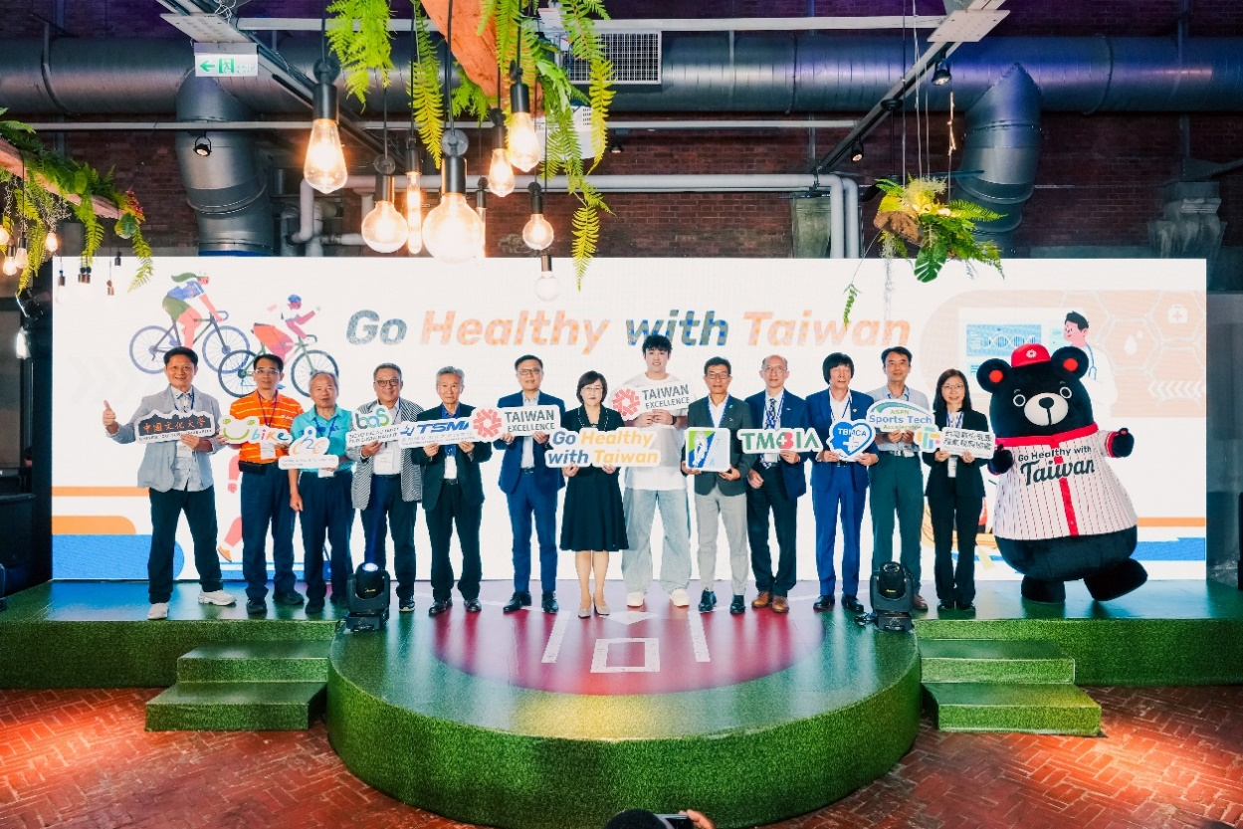

Representatives from industry, government, and academia in the health sector attended the event, joining forces to shape a “Healthy Taiwan” and foster global well-being.
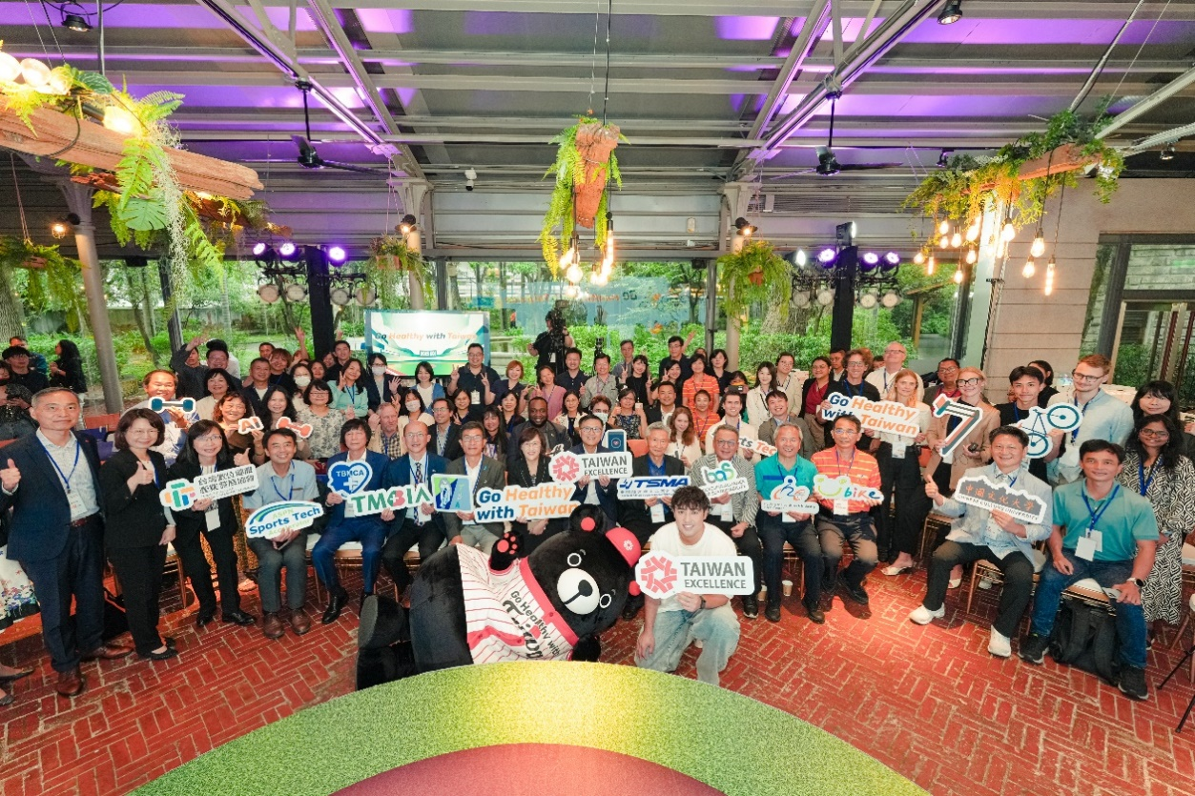

Industry representatives, media, and diplomats gathered to show their support.

