Application for Rental of Venues at the Business Startup and Incubation Division, Academia-Industry Collaboration Center (Central Taiwan Science Park Campus)

Company Name / Title: Business Administration No.:
Contact Person: Sector: Position Title: Telephone: FAX： E-MAIL： -
Address:
★ Source of Rental Information about Central Taiwan Science Park Venue:
- Internet □ Used to Attend Class at the Venue □ Recommended by Family/Friends/Colleagues □ Electronic Direct Mail □ Paper Direct Mail □ Others

Event Venue | - Classroom 201 (48-56 Persons) □ Classroom 206 (30 Persons)
Event Venue | - Classroom 202 (48-56 Persons) □ Lounge 211 (50 Persons)  - International Conference Hall 212 (138 Persons)
Event Venue | ★ ★★ Equipment Borrowing: Please fill in “Equipment Rental Form”. Pay the rental fee together with the venue rent.
Date of Use | (m) (d) (y) (Time: : to : _ ; Totaling session(s))
Event Name
Event Content | - Education and Training □ Seminar □ Presentation □ Speech □ Meeting □ Others
Payment | - Bank Remittance: First Commercial Bank (Taichung Branch); Account Name: National Chung Hsing University School Fund Special Account 401; Account Number: 4013 0099 556
Payment | Aggregate Amount: NT$  (This unit is affiliated to Incubation promotion sector; thus the receipt/invoice shall be issued according to the regulations of the School.)

Representative of Rental Agency:
Date:

(Please send the above information when it is completed and call to confirm, Tel: 04-36068996 ext. 1008 Mr. Liu; Fax: 04-3606-8995)

Reviewer Comments (Filled in by Chung Hsing University)
- Rent Agreed (Payable: Total NT$
- The applied venue is unavailable.

Case  Officer |  | Supervisor

●Venue Rentals (Weekdays)

Venue Category (Capacity) | Venue No. | Venue Rental (tax exclusive) | Venue Rent Payable  (tax inclusive) | Basic Equipment (Hereinafter including 1 poster board and  1 reception desk)
General Classroom  （48-56 Persons） | 201,202 | NT$5,000 | NT$5,250 | 24 desks, 48 chairs, whiteboard, lectern, mono-projector, screen, 1 microphone
General Classroom  （30 Persons） | 206 | NT$3,000 | NT$3,150 | 15 desks, 30 chairs, whiteboard, lectern,  mono- projector, screen, 1 microphone
International Conference Hall  (138 Persons) | 212 | NT$10,000 | NT$10,500 | 138 conference chairs, digital multi-media lectern, rising-falling mono- projector and screen, whiteboard and 2  microphones
Lounge (50 Persons) | 211 | NT$5,000 | NT$5,250 | L-shaped sofa set (including cabinet  (meal) table, coffee table), 6 negotiating tables, 24 conference chairs
(This unit is affiliated to Incubation promotion sector; thus the receipt/invoice shall be issued according to the
regulations of the School)
●Notes:
- Venue Available Duration for Booking: 9:00-12:00 a.m.; 14:00-17:00 p.m.; Evening: 18:30-21:30.
- If the venue needs to be arranged before the event, please inform us in advance, and this Unit will evaluate whether to price or not according to the layout.
- Please call us in case of need for renting other classroom equipment.
- If large-scale electricity (220/380v) is needed, a cost of NT$200 / hour (tax exclusive) is required.

Equipment Lease Request Form
Applying Unit
A p p l i c a n t |  |  | P ho n e N u mb e r |  |  |  | Application Date
E ve nt N a m e
Free Items:
- Mono-Projector
- Projection Screen
- 1 Poster Board
- 1 Wired Microphone
- 1 Wireless Microphone (only for classrooms with more than 30 people)
- 1 Reception Desk
- 1 Trash Can
Charge Items | - Notebook Computer (NT$1000)  - Mobile Mono-Projector (NT$500)  - Poster Board (big: NT$100; medium: NT$50)  - Microphone (NT$100) |  |  | - Classroom Chair (with wheels) (NT$100)  - Laser Pointer (NT$50)  - Classroom Desk (NT$200)  - Foldable Desk (NT$100)  - Whiteboard (NT$100) |  |  |  | - Foldable Desk (NT$50)  - Tablecloth (NT$50)  - Place Card (NT$10)  - Extension Cord (NT$50)  - Video Conference Facilities (NT$1500)  - Others
Record | Collect |  |  |  |  | Return
Record | Date: (Day of the week: ) Time: |  |  |  |  | Date: (Day of the week: ) Time:

Applicant | Case Officer | Belongings Custodian | Acceptor For Returning Belonging

  - Borrowed equipment is limited to the use in administrative or teaching related activities in this Building.
  - Any damage during the equipment borrowing process shall be compensated according to the original purchase price.
  - The poster board can only be placed in the indoor venue, and compensation is required in case of damage.

Venue Application Rules and Notices

- The user shall fill in the Venue Booking Application Form in advance.
- Units on Campus: relevant documents for the activities shall be submitted five days before the date of use.
☆ Units on Campus are given a 40% discount on the venue rental for non-profit activities
(excluding cleaning fees and equipment rental fee). Discounts are not available for profit

making activities.
- Off-Campus Units: Please submit relevant documents such as agenda, plans, and file an application one week before the date of use.
☆ Government agencies are given a 20% discount on the venue rental (excluding cleaning fees
and equipment rental fees).
- Within seven days after the approval of the application, the borrowing unit shall remit the venue rental to the following bank account: Bank: First Commercial Bank (Taichung Branch); Account Name: National Chung Hsing University School Fund Special Account 401; Account Number: 40130099556. And then the borrowing unit shall fax the remittance receipt to the “Division of Innovation Incubation, General Center for
Academia-Industry Collaboration (Central Taiwan Science Park Campus)” 04-36068995 (please confirm after fax) to help issue the receipt or invoice according to the relevant regulations of the School, and complete the booking procedure.
- The activity project shall be carried out according to the application content stated in the Venue Booking Application Form. Otherwise the Division of Innovation Incubation has the right to suspend the event, and the borrowing unit shall still pay the total amount of the fees.
- The rental fee shall be paid in accordance with the regulations before use; the Division of Innovation Incubation has the right to make arrangements for the venue before the booking

procedure is completed.
- In the event of natural disasters or other accidents, which might render the rental facilities unusable, the rental unit may alternatively choose another day for the use.
- If the rental unit desires to change the scheduled venue and time, it shall negotiate with the Division of Innovation Incubation one week before the original scheduled date; otherwise the prepaid rent will not be refunded.
- If the rental Unit wishes to cancel the scheduled venue, it shall notify the Division of Innovation Incubation two weeks before the original scheduled date; otherwise no refund is available.

- The first and second floors of the Building are equipped with: lectern, mono-projector, projection screen, whiteboard, etc. Mobile mono-projectors are available for rent. Please borrow them (and other equipment) according to the regulations if needed.
- For the borrowed equipment, instrument, etc. in the venue, any damage shall be borne and compensated by the borrowing unit. If any equipment or instrument in the venue are found to have defects or damages when borrowed at the Division of Innovation Incubation, the borrowing unit shall immediately notify the responsible person of the Division of Innovation Incubation of such defects or damages; if the borrowing unit did not notify the person of the Division of Innovation Incubation at the first place, leading to the damages occurred or expanded, the damages shall be borne and compensated by the borrowing unit. In case of violation of the provisions herein, the applications shall be rejected.
- The equipment and articles to be used during the event shall be approved by the management unit of the Building before being stored and installed in advance. After the event is over, the various items and equipment shall be moved away within the time limit. Otherwise, the Building will not be responsible for the storage and will dispose of what is considered waste, and the disposal fees will be paid by the borrowing unit as the case may be.
- If the applying unit needs to post their posters and place publicity materials, those may be placed

at the designated place after being approved. When the event is over, the venue should be restored to its original state the sooner the better. During the activity, stipulating that smoking is prohibited in all places in the Building, and food and beverages are prohibited in the conference room and classrooms shall be required.
- In order to maintain the architecture, soft and hardware facilities of the campus buildings, the Division of Innovation Incubation may collect venue fees (including the fees for basic equipment, general lighting, air conditioning, venue cleaning, etc. Please refer to the “Venue Rentals”.) from the borrowing units, and the payment shall be made immediately after the rental procedures are completed according to the regulations (please refer to the “Venue Application Rules and Matters Need Attention”). Upon approval of the borrowing, the venue rental fee shall be paid to the designated account and the receipt shall be used to enter the venue. The cleaning of tea, snacks and garbage shall be carried out by the borrowing unit and should following the resource recycling standards. If the borrowing unit fails to carry out the waste sorting according to the regulations leading to the punishment imposed to the Building, the applications will never be
accepted afterward.
- The venue fee is calculated according to the time sessions.
(1) The time sessions are: 09:00~12:00; 14:00~17:00; 18:30~21:30.
(2) Overtime use: The overtime charge shall be calculated hourly based on the proportion of the charge for each time sessions. Less than one hour shall be computed as one hour.
- Other unsettled matters shall be based on the “Regulations Regarding National Chung Hsing University Venue Use Management and Charges” adopted by the Administrative Council on January 9, 2002.

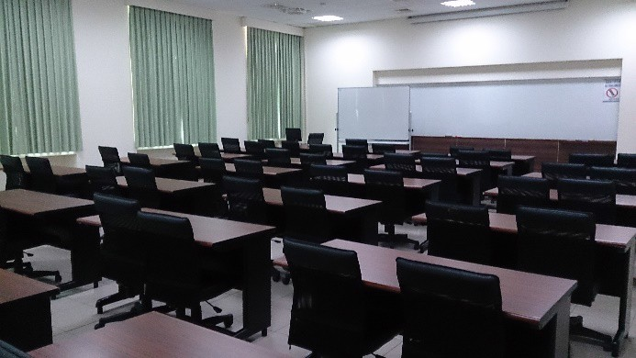 | 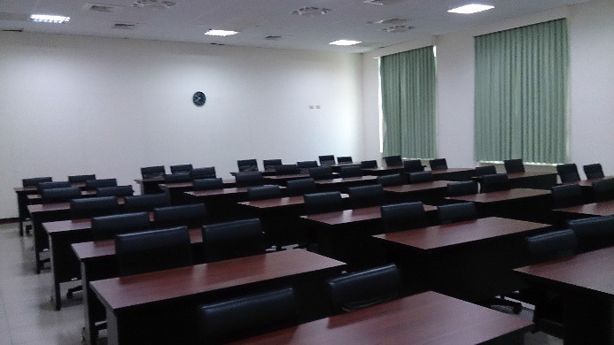
Conference Room 201 Live View Photo-1 | Conference Room 201 Live View Photo-2
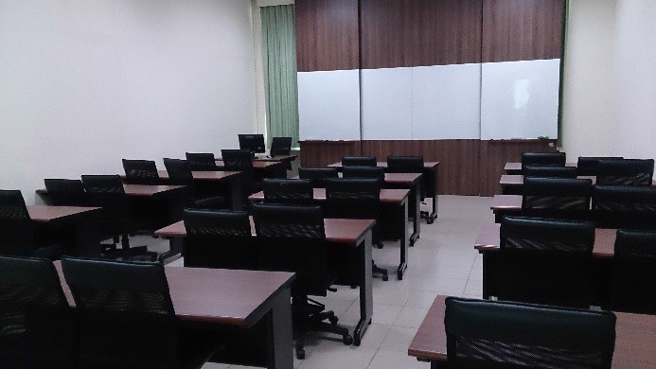 | 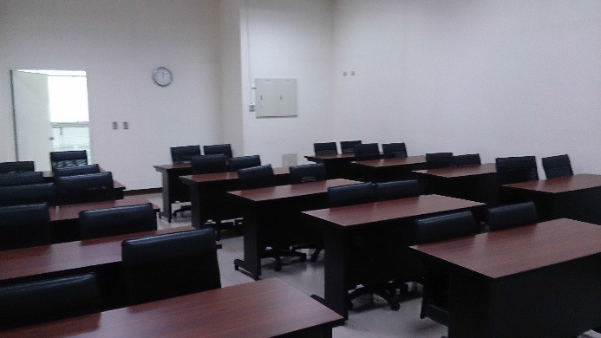
Conference Room 206 Live View Photo-1 | Conference Room 206 Live View Photo-2
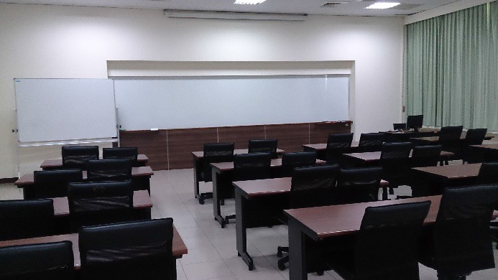 | 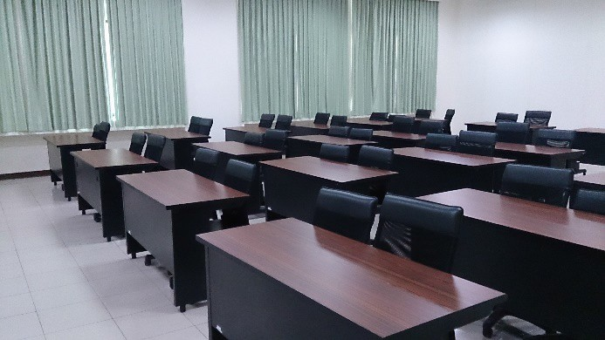
Conference Room 202 Live View Photo-1 | Conference Room 202 Live View Photo-2
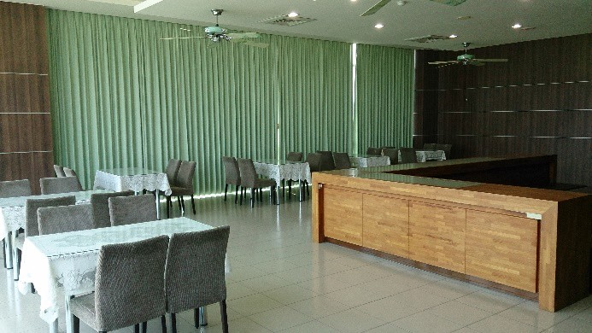 | 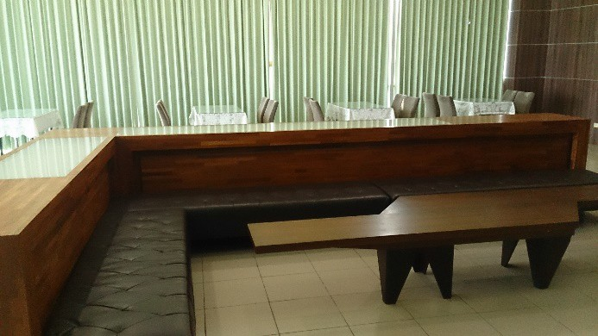
Lounge 211 Live View Photo-1 | Lounge 211 Live View Photo-2

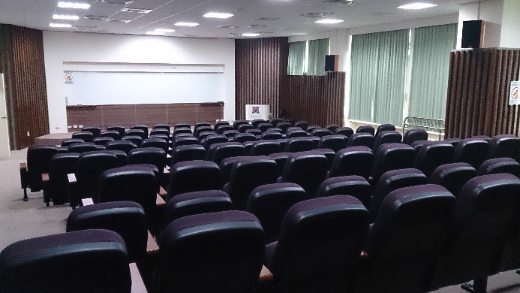 | 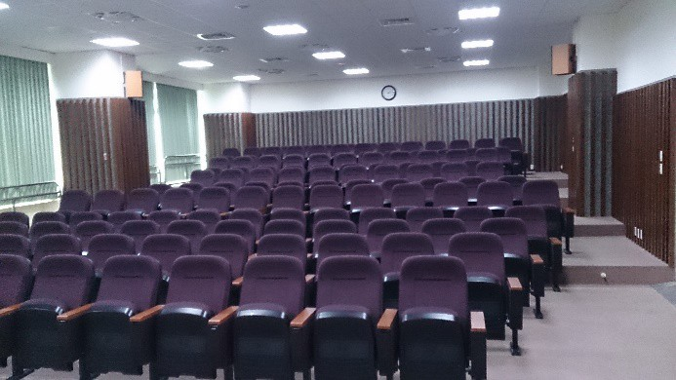
International Conference Hall 212 Live View Photo-1 | International Conference Hall 212 Live View Photo-2
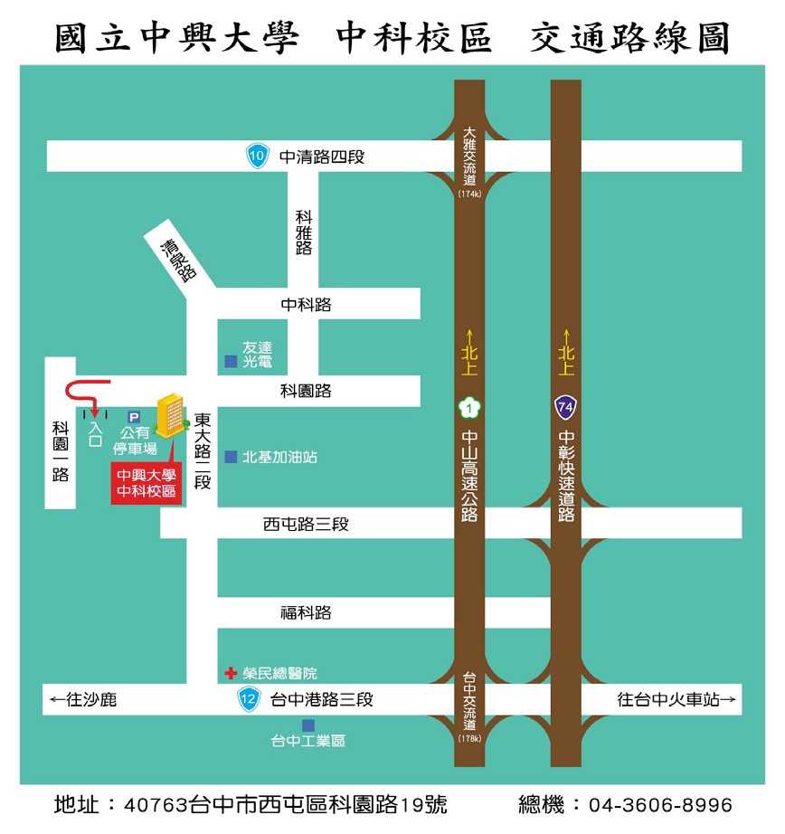
國立中興大學中科校區交通路線圖
Traffic Road Map of National Chung Hsing University Central Taiwan Science Park Campus

中清路 4 段
Sec. 4, Zhongqing Rd.

科雅路
Keya Rd.

中科路
Zhongke Rd.

清泉路
Qingquan Rd.

科園路
Keuan Rd.

科園一路
Keuan 1st Rd.

東大路２段
Sec. 2, Dongda Rd.

西屯路 3 段
Sec. 3, Xitun Rd.

福科路
Fuke Rd.

台中港路 3 段
Sec. 3, Taichung Port Rd.

往沙鹿
Heading to Shalu

大雅交流道

Daya Interchange

北上
Northbound

中山高速公路
Sun Yat-sen Freeway
中彰快速道路
Provincial Highway No. 74

台中交流道
Taichung Interchange

往台中火車站
Heading to Taichung Train Station

友達光電
Au Optronics

公有停車場
Public Parking Lot

入口
Entrance

中興大學中科校區
Chung Hsing University Central Taiwan Science Park Campus

北基加油站
NSP Gas Station

台中工業區
Taichung Industrial Park

地址:台中市西屯區科園路 19 號 總機: 04-3606-8996
Address: No. 19, Keuan Rd. Xitun Sec., Taichung City

Switchboard / Tel: 04-3606-8996

